- The research question I will be answering in this study is the following: Can a multiple linear regression model predict an e-commerce customer’s order value based on the data included in Sewell’s dataset (Sewell, 2026)? The data used is Sewell’s e-commerce customer retail sales dataset, which includes various factors surrounding basic customer demographics as well as discount groups. Understanding the most important variables that correlate with order value can improve business insight into why order value may increase between customers. Lin (2024) used the same method to predict overall Walmart location sales based on various business-related factors. Although they looked at overall sales predictions, the same approach can be used on a customer-by-customer basis to identify correlating factors. The research found that weekly sales can be influenced by various factors, with a handful of factors having significant practical significance (Lin, 2024). To conduct whether the model can predict order value, there are two requirements, all variables in the final equation must have coefficient that is not equal to 0, and the adjusted $R^{2}$ score of the final test model must be greater than or equal to 0.66, meaning that it must capture more than or equal to 66 percent of the variance in the order vales. The anticipated outcomes of the project are the following: to create a multiple linear regression model that can accurately predict e-commerce customer order value (in dollars) based on statistically significant factors and finding what the statistically significant factors for order value are. As stated by İnce & Taşdemir, “For industry practitioners, the clear delineation of influential market drivers and their impacts on sales forecasts offered actionable insights” (İnce & Taşdemir, 2024).
- Report on data-collection
I manually downloaded the data, in .csv format, from Kaggle. The advantage of collecting the data this way is that it does not require one to have a Kaggle API Token to download the data. The disadvantage to this method is that one must download the latest version of the data every time they want to update their data rather than having Kaggle API automatically download the latest version. As downloading the data was as simple as clicking download on the Kaggle website, I did not have any issues with data collection/downloading.
- Data extraction and preparation
Overall justification for use of Python over R or SAS:
When comparing Python vs R, there are not many differences in creating the regression model, with statsmodels. As stated by IBM: “The main distinction between the two languages is in their approach to data science. Both open-source programming languages are supported by large communities that continuously extend their libraries and tools. But while R is mainly used for statistical analysis, Python provides a more general approach to data wrangling… the R vs. Python debate is all for naught” (Python vs. R: What's the difference? 2024). For SAS, as stated by Pereira, “There is very little that SAS can do that R and Python cannot. Statistically, R covers the same ground and often goes further. Python fills the engineering and ML gaps. Between the two, the functional coverage is broad.” (Pereira, 2026).
- Data import
I began by importing the data into a dataframe
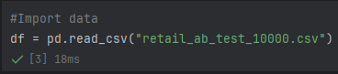
Justification: As I downloaded the data manually, I just needed to import the data into a dataframe.
Advantage/Disadvantage: I went into detail in the previous section about manual/programmatic data download/collection.
- Filtering data
I began by filtering the data to only include records that included a purchase (where purchased is not 0).
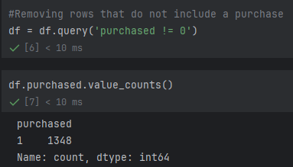
Justification: As I am looking to build a model to predict non-zero order_value values, I do not need to include values that do not have a purchase.
Advantage: For this scenario, .query() is easier to read and for the purpose that it provides, creating a copy of the dataframe based on the query is what I was looking for.
Disadvantage: Using another method, such as .loc. would be computationally faster on this dataset due to the size.

- Removing unneeded rows
After filtering the data, I removed the variables that are not needed for analysis.
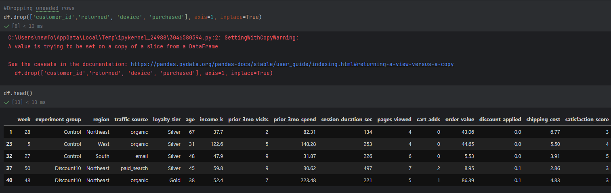
Justification: As I will not be using these variables in analysis, removing them makes the process easier to follow.
Advantage: .drop() is quicker to write than other options as you choose what to remove rather than other options that you select what you keep.
Disadvantage: using del and iterating over the columns could be a faster alternative to using .drop.
- Data splitting
I then split the data into three dataframes; df_xFeatsCat, df_xFeatsNum and df_yFeat. I did this so that it would be easier to do proper transformations as well as create visualizations more easily.
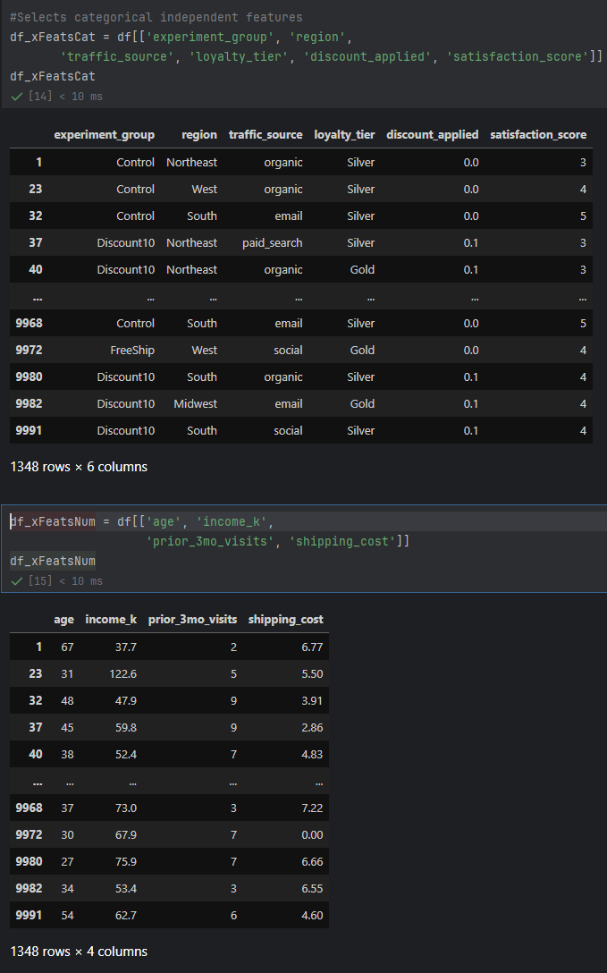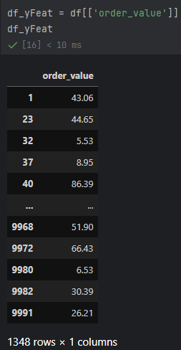
Justification: I split the data so that each dataframe can go through their own transformations independent of one another using iterative methods.
Advantage: Using df[[]] is easier to write and look at as it uses column names.
Disadvantage: Using .iloc or .loc could be faster computationally.
- Descriptive Analytics
Once I split the data, I found the descriptive analytics for the numerical features as well as the categorical features. 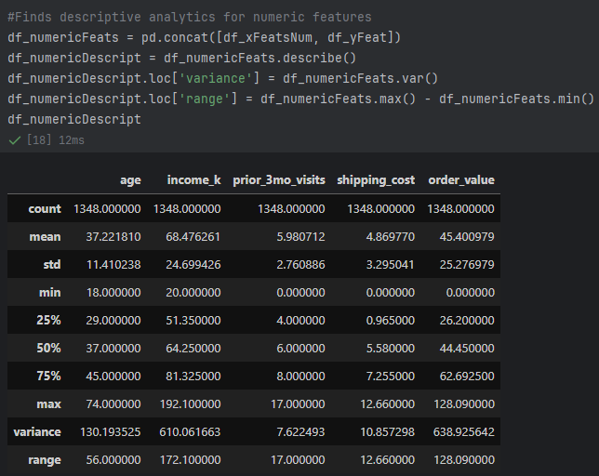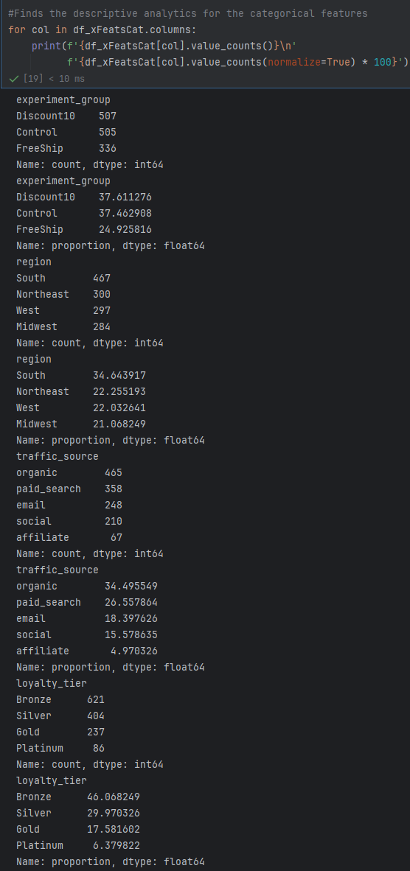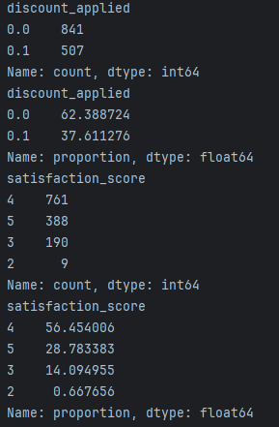
Justification: I found the descriptive analytics for each variable as it allows for more meaningful insight during future processing.
Advantage: The descriptive analytics are iterated over each column in the dataframe that they use, making it require less lines of code. I also included extra descriptive analytics in the numeric section that are not typically included in .descrbe().
Disadvantage: The output of the categorical analytics is poorly formatted and can be hard to read.
- Univariate and Bivariate Visualizations
After finding descriptive analytics, I created simple visualizations of the features, a univariate visualization for each variable, and a bivariate visualization to show the relationship between each independent variable and the dependent variable. I created a function to create the visualizations for the numeric features as I knew I would need to deal with outliers that I spotted during descriptive analytics, so I would need to recreate the visualizations later.
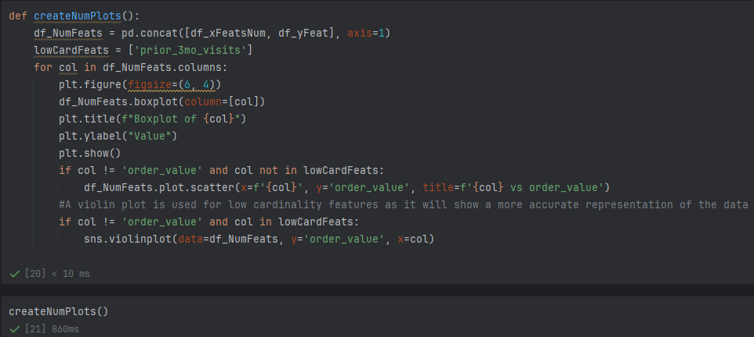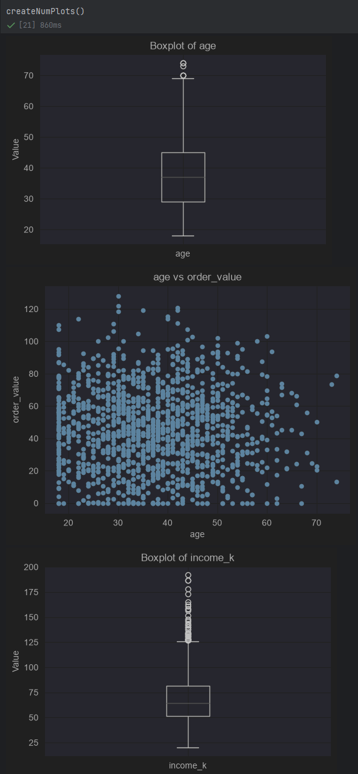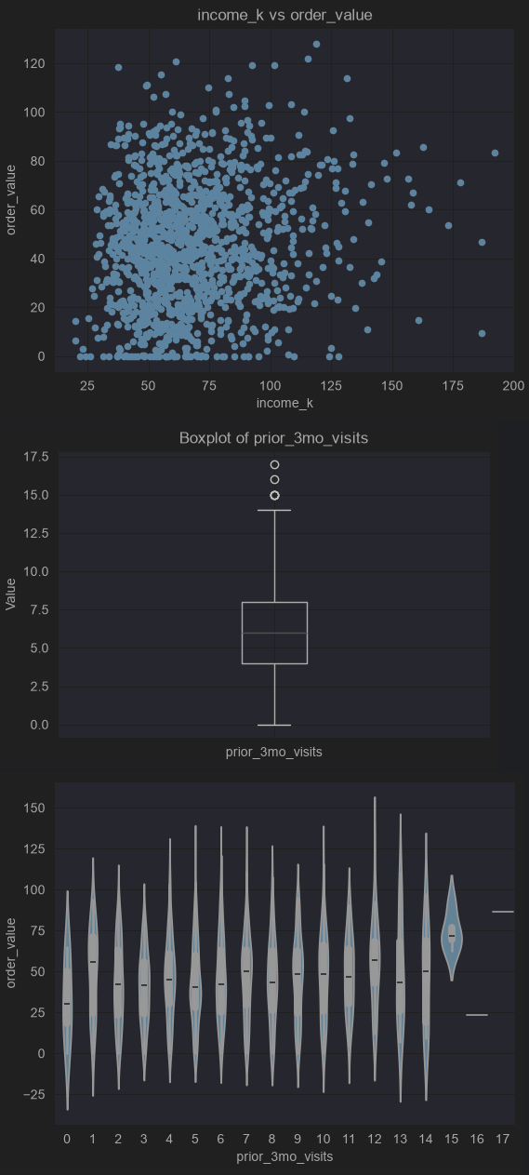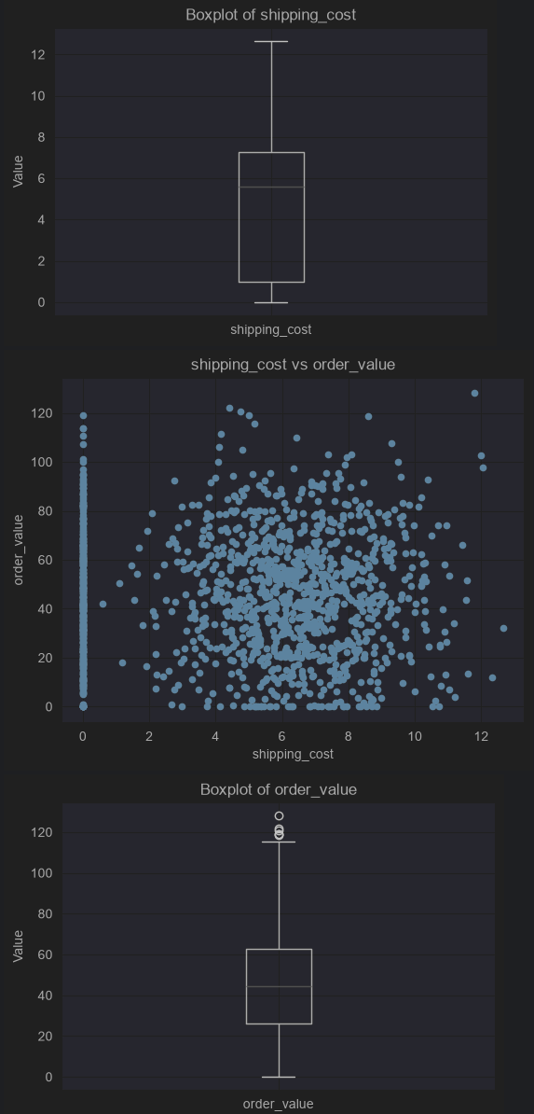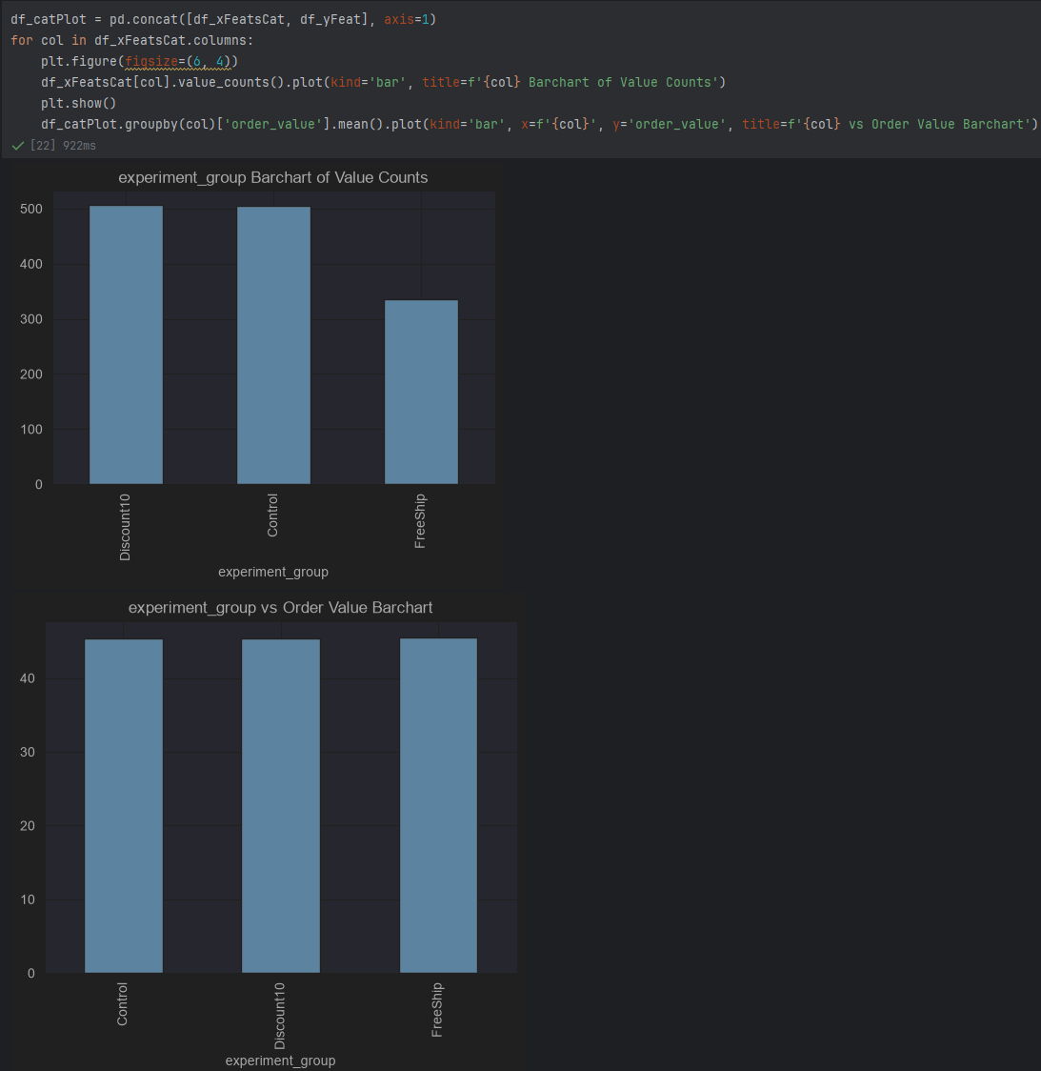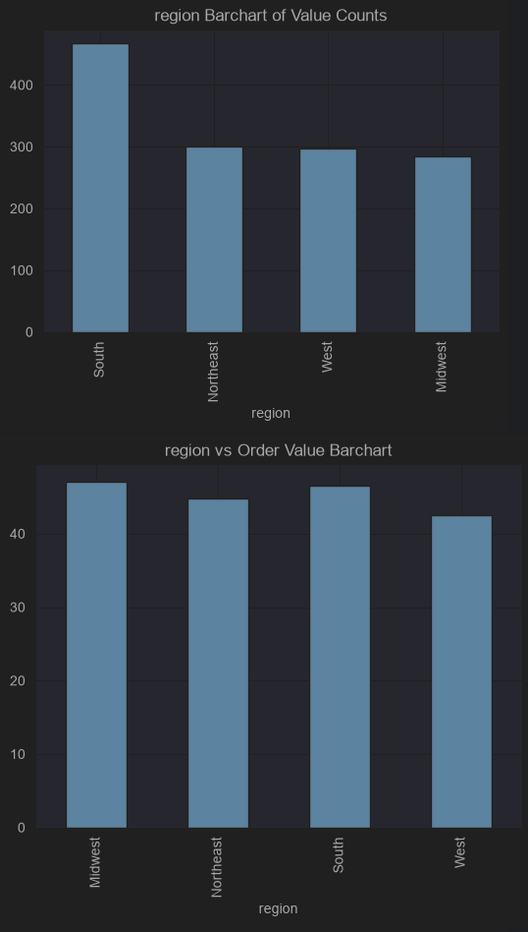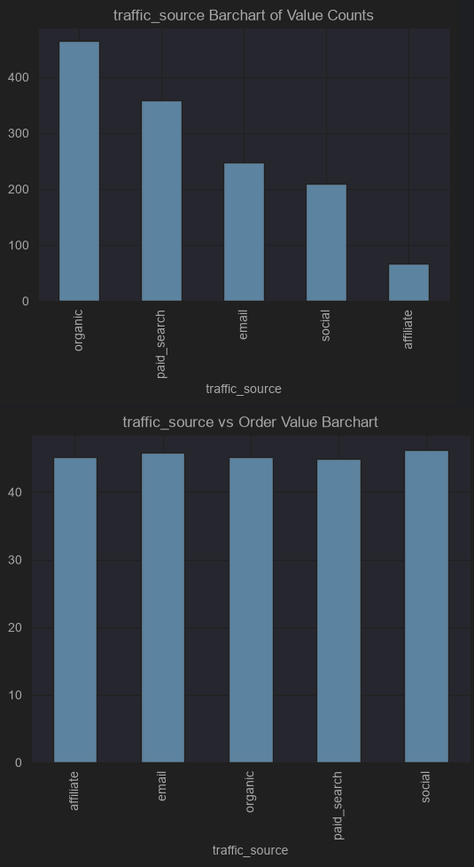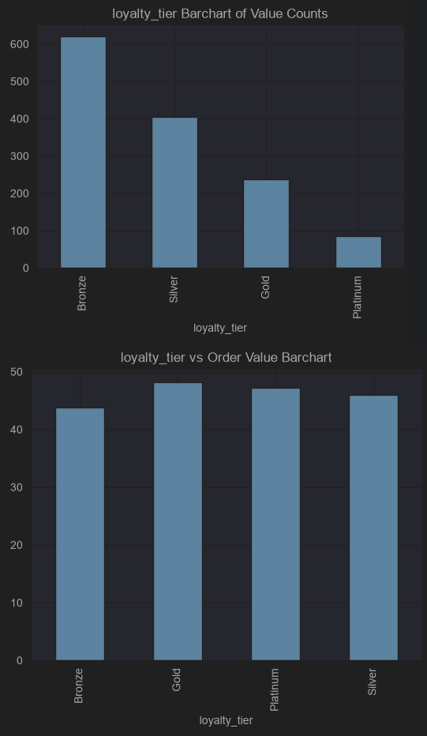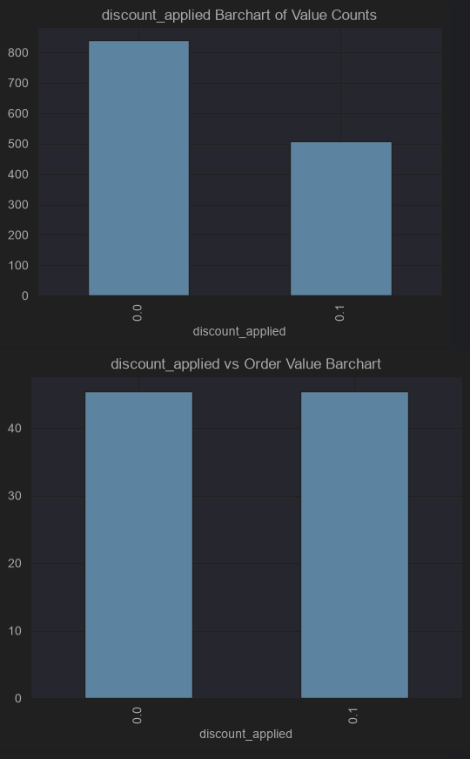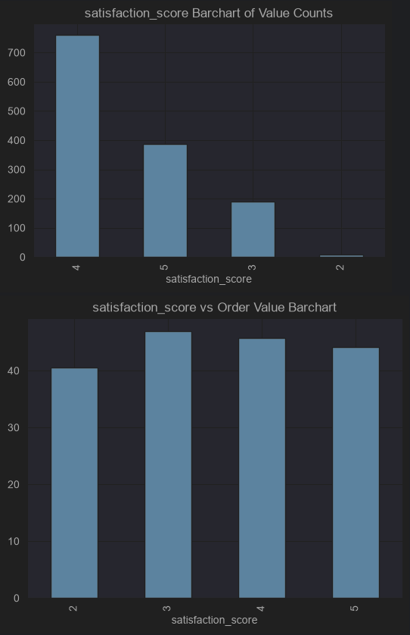
Justification of visualizations: I used boxplots, scatter plots, and a violin plot for the numeric features as the boxplots are a great univariate visualization to represent a single variable’s descriptive analytics in a visual format. Scatter plots are a great way to show the relationship between two variables with medium to high cardinality, it is easy to see what kind of relationship there are between two variables in this format. I used a violin plot in place of a scatter plot for the low cardinality variable as it works similarly to how a bivariate boxplot would work but also shows frequency, which adds another layer of information. For categorical features I only used bar charts. Bar charts can be both bivariate and univariate visualizations, for univariate visualizations, it shows frequency of values in a single variable, for bivariate it shows the average value of the dependent variable for each possible value in the independent variable.
Advantage: There are less lines of code used as there are short code blocks that iterate over each variable rather than having lines of code dedicated to each variable.
Disadvantage: The output is hard to read through due to the way that the output is shown in Jupyter notebooks. It is also hard to create specific kinds of visualizations for variables that need to use a different visualization type from the default, as seen in the numeric section where I used a violin plot.
- Dealing with outliers
After creating the visualizations, we can see that there are many outliers in the numeric variables, to deal with these, we are going to use winsorization. Winsorization sets a limit to the values in a variable, in this case as all the outliers are upper-bound outliers, we are going to limit how large the values can be. 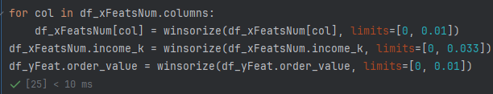
Justification: I personally like to use winsorization when dealing with numeric outliers as it is a great way to deal with outliers without removing data or removing the effect of the outliers as data points (Couto da Silva, 2025).
Advantage: Winsorization is a great way to deal with outliers without removing data or removing the effect of the outliers as data points.
Disadvantage: Winsorization can alter the distribution of data points through capping values.
- Creating dummies for categorical variables.
Once I had the numerical variables prepared for analysis, I needed to create dummy variables for the categorical variables. While creating dummy variables I also changed the discount_aplied variable to be a true/false variable by mapping the values to be true/false (1/0). 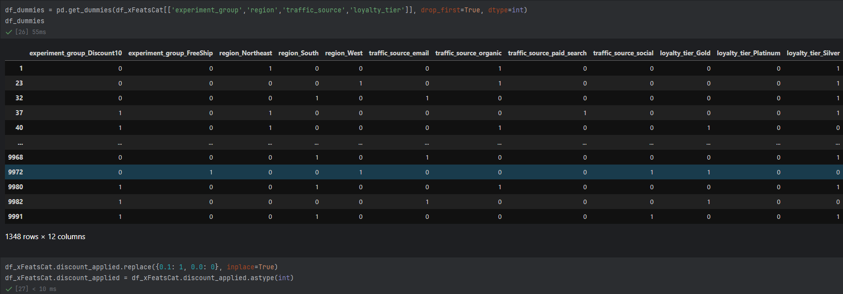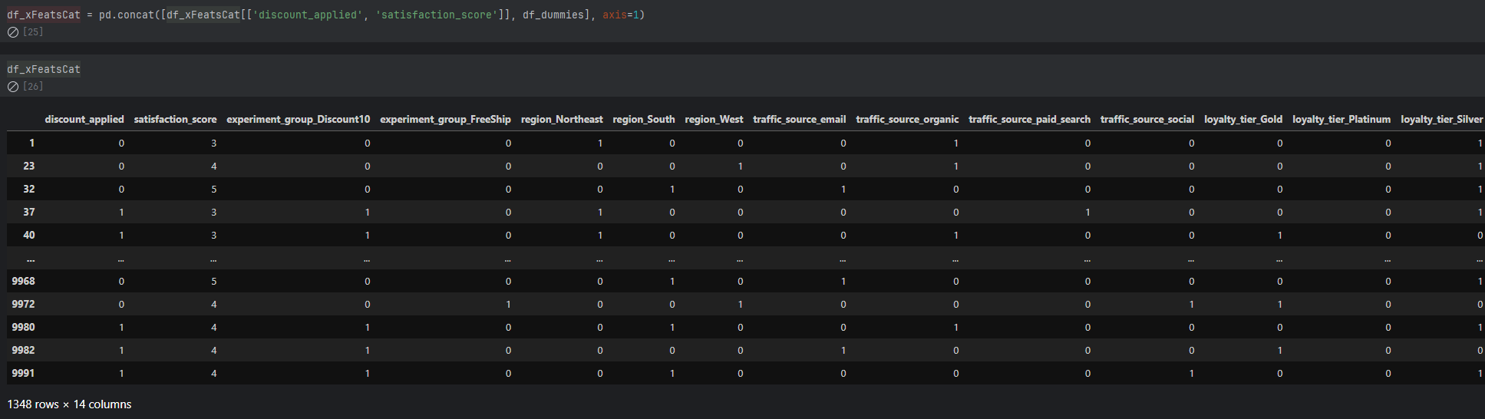
Justification: I kept the satisfaction_score variable the same as it is an ordinal variable and can be kept the same.
Advantage: Using iteration to go through most of the variables to create dummies reduces the number of lines of code.
Disadvantage: Iteration does not allow creating dummies on a case-by-case basis, and I dropped the first dummy created, which may not always be the control group for each variable, in this case it happened to be the control group for the experiment_group feature.
- Joining dataframes back together.
Once I was finished with the data processing, I needed to join the independent variables back together. This started with joining the final categorical variables together, then joining them to the numerical independent variables. 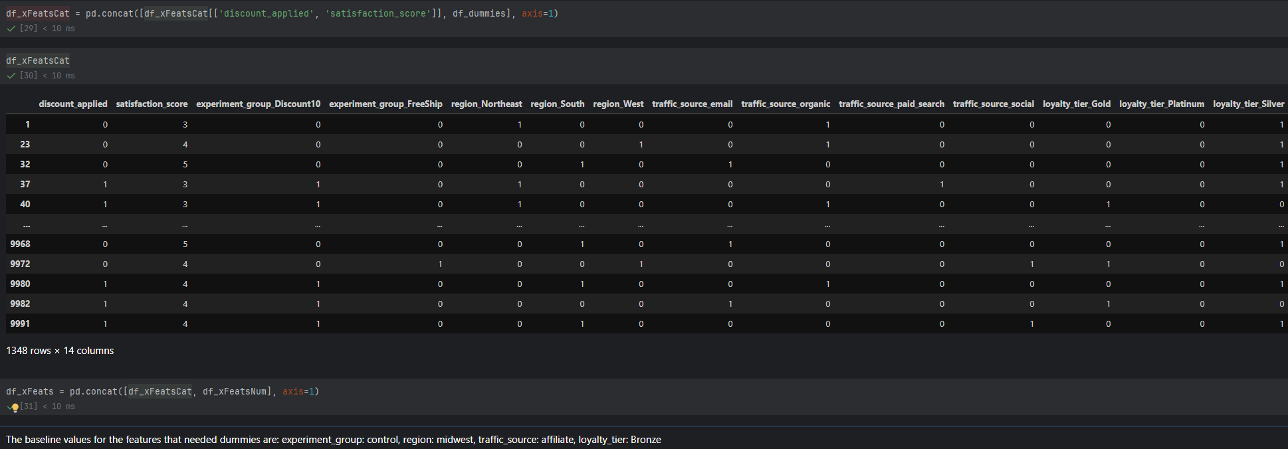
Justification: I joined the dataframes together in this manor so that it would be easier to inspect the categorical variables and the numeric variables using the previous techniques used to create visualizations and descriptive analytics.
Advantage: Keeping the joining in two steps allows for recreation of visualizations and descriptive analytics as stated before.
Disadvantage: The dataframe joining could have occurred in one step to reduce the amount of code.
- Pre-analysis | Data splitting and scaling
I included the data splitting and scaling in both this section and the analysis section as this process could be seen as a part of both processes. To split the data, I used sklearn’s train_test_split function to keep 20% of the data for testing, I used a random state of 42 so that the results would be the same if someone else ran the notebook. I also used sklearn’s standard scaler to scale the data. Each of the data sets are saved to .csv files for reproducibility. 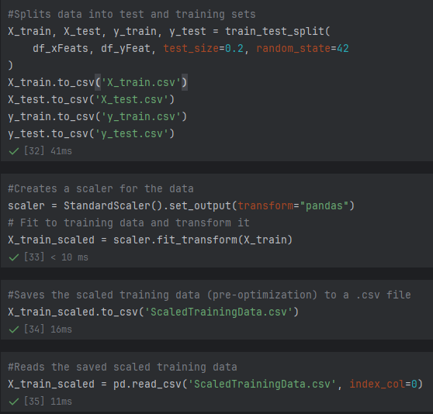
Justification: I split the data into training and test sets so that the model could be tested for over-/underfitting, and I scaled the data to ensure there would not be feature dominance in variables with larger values.
Advantage: Splitting and scaling the data allows for improved model training and testing.
Disadvantage: The sklearn methods to split and scale may not be the best performance method to perform these processes.

- Analysis
Overall justification for the use of Python over R or SAS is included at the begging of the previous section.
- Data splitting and scaling (Also included in the data extraction and preparation section)
I included the data splitting and scaling in both this section and the data extraction and preparation section as this process could be seen as a part of both processes. To split the data, I used sklearn’s train_test_split function to keep 20% of the data for testing, I used a random state of 42 so that the results would be the same if someone else ran the notebook. I also used sklearn’s standard scaler to scale the data. Each of the data sets are saved to .csv files for reproducibility.
Justification: I split the data into training and test sets so that the model could be tested for over-/underfitting, and I scaled the data to ensure there would not be feature dominance in variables with larger values.
Advantage: Splitting and scaling the data allows for improved model training and testing.
Disadvantage: The sklearn methods to split and scale may not be the best performance method to perform these processes.
- Initial Regression Model
After splitting and scaling the data I ran the initial OLS model.
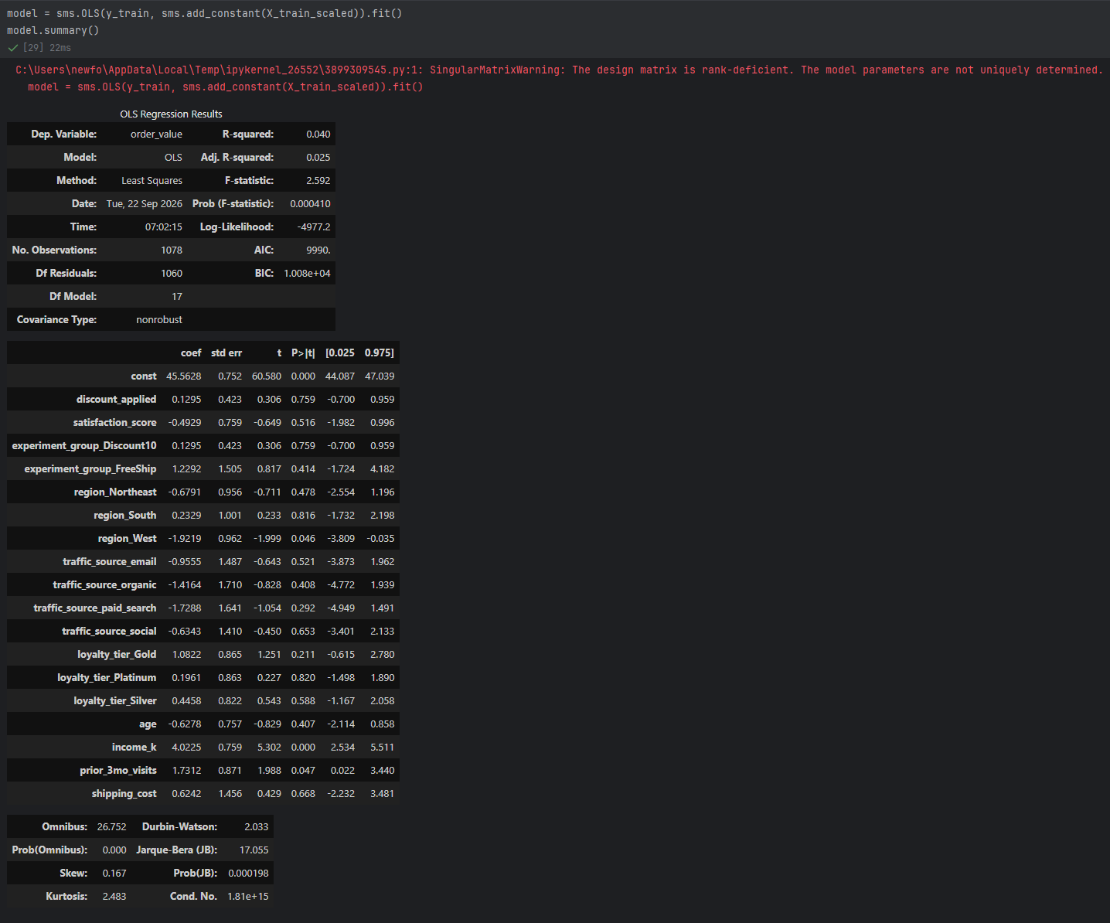
Justification: I chose to use statsmodels’ OLS regression as more information can be gained from the model compared to other multiple linear regression models like sci-kit learn’s.
Advantage: The regression model contains more information than other linear regression models.
Disadvantages: Sci-kit learn’s model is better at predicting values rather than looking at statistical values.
- Feature elimination
Using forward stepwise elimination, I selected features that were statistically significant, I then needed to add other dummy variables for the original region variable, as the stepwise elimination kept one of the dummy variables. 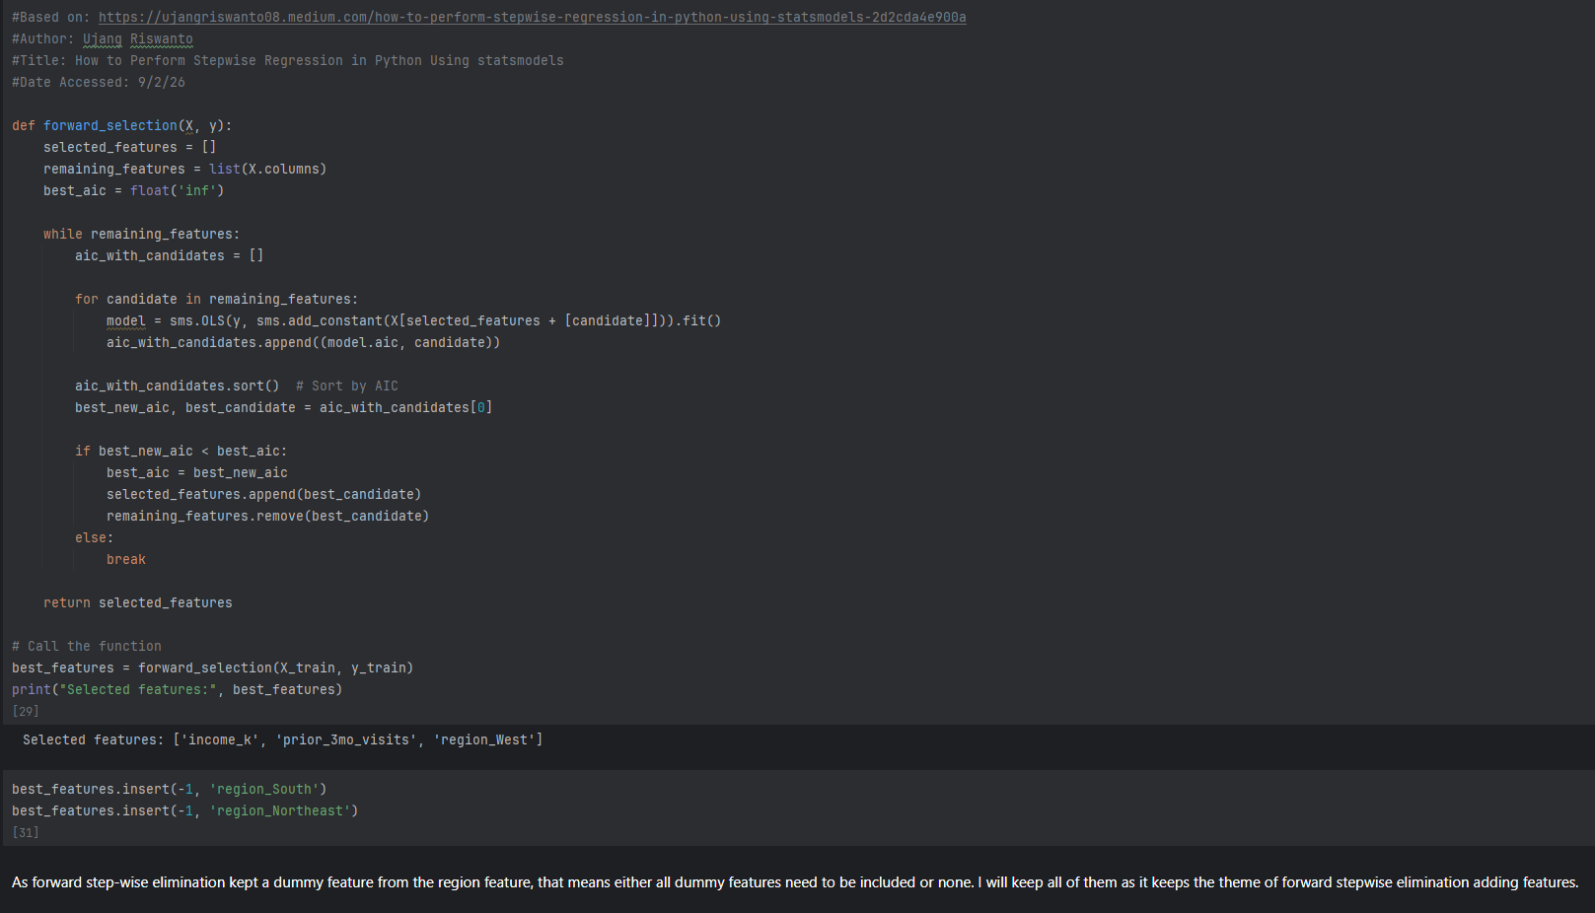Justification: I used forwards stepwise elimination as it takes an approach where only statistically significant features are kept. As feature selection kept one of the region dummy variables, I needed to manually add the other region variables or remove the region_West. I chose to keep all region dummy variables as adding more features fits the theme of forward selection, and it should make the model more accurate.
Advantages: Forwards stepwise elimination is computationally more efficient than other methods and simplifies the number of selected features.
Disadvantage: Forwards stepwise elimination can distort p-values and overfit the model. Adding the other region dummy variables can also negatively impact the adjusted $R^{2}$ score due to the addition of less significant variables.
- Final Trained Model
Before testing the model, I did a final train using the newly selected features. 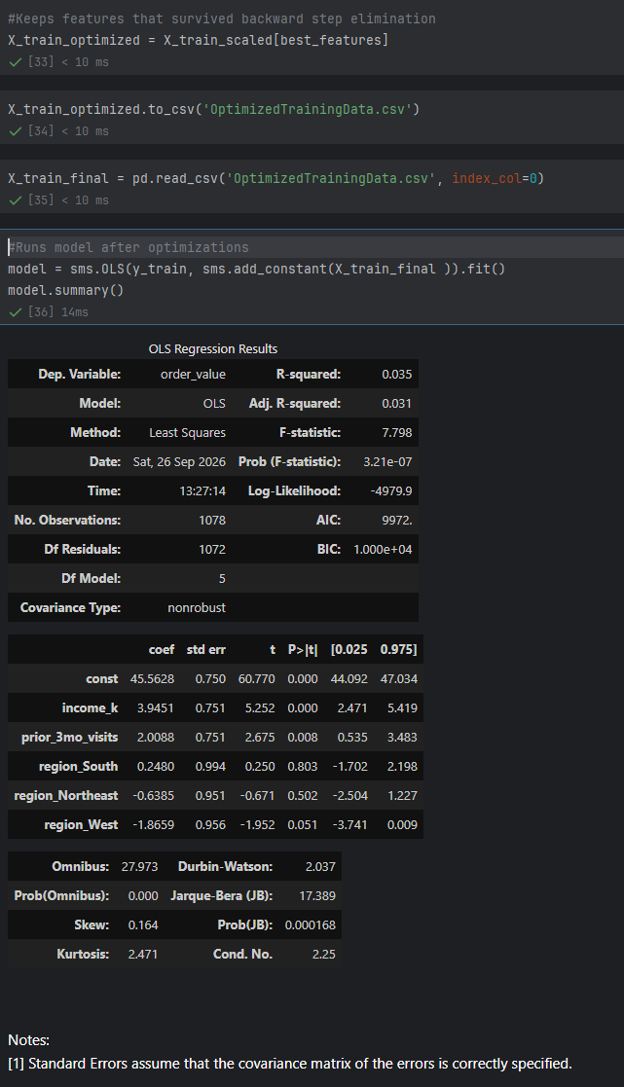
Justification: Before testing the model, the model needed to be trained using the selected features from elimination. I saved the optimized training set as a .csv for reproducibility.
Advantages/disadvantages: I believe that there are no advantages or disadvantages in this step as the model must be retrained after feature selection. The choice to save the optimized training set to a .csv file can be discussed for its advantages or disadvantages, but it does not change the fact that the model needs re-trained.
- Final Test Model Predictions
Once the model has gone through final training, the model can be used to predict order values. This also includes performing the same changes to the training set that we used on the test set, including scaling and including only selected features.
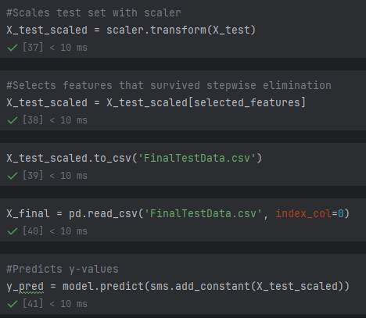
Justification: Before the model can run predictions, the test set needs to have the same transformations that occurred to the training set done on itself, which includes scaling, and only keep features that were selected. The final testing data was saved to a .csv file for reproducibility.
Advantage/Disadvantage: I believe there is no advantage/disadvantage to doing this step, the model type can be discussed as it previously was during the Initial Regression model section.
- Model Statistics
After using the model to make predictions with the test set, statistics around the model needed to be calculated, this includes: training and test set residuals, root mean square error (RMSE) for both train and test sets, mean absolute error (MAE) for both sets, as well as the $R^{2}$ and adjusted$R^{2}$ values of both sets. 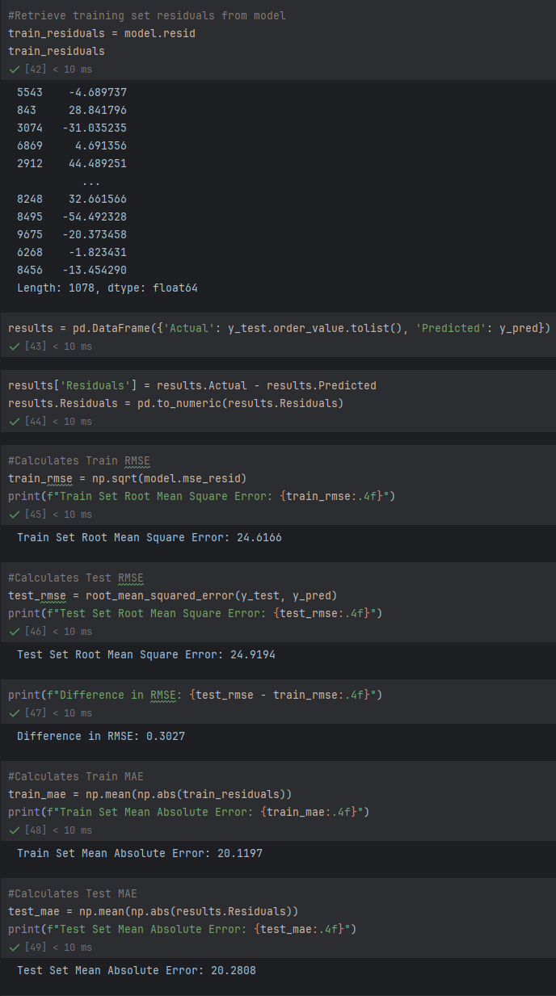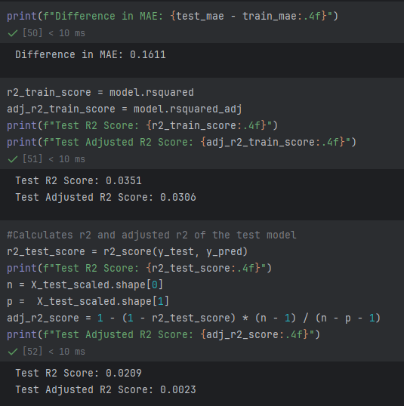
Justification: The residuals are calculated for use in the next sections to check the assumptions of multiple linear regression through multiple tests. The MAE and RMSE are used to check over and underfitting through comparing error values between the groups (Alaudeen, 2025). Discussion of the error values will be explored in the implications section. The $R^{2}$ and adjusted $R^{2}$ values are calculated to test model accuracy to see how much variance they predict, the adjusted $R^{2}$ is used to ensure the model is not overly complex by punishing the inclusion of too many variables (Alaudeen, 2025). Discussion of all statistics will be included in the implication section.
Advantages: Calculating these test statistics allow further scrutiny of the model through the ability to check multiple factors, including model fitting, model error, and model accuracy. Using these methods, it allowed for a simplified way of calculating and obtaining these statistics.
Disadvantages: There are other ways of calculating these statistics using other methods that could be computationally less intensive or more simplistic.
- Equation creation
Once the test statistics were created, I turned the output of the model into an equation. 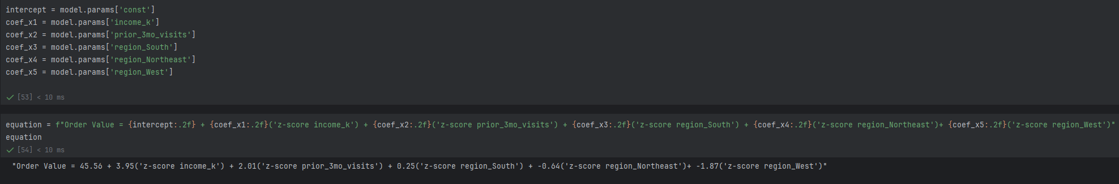
Justification: I decided to manually create the equation by extracting the intercept and coefficients from the model and creating a string with these values.
Advantage: It is very simple and easy to follow and does not have any errors as the equation is created manually.
Disadvantage: As the equation is created manually, if new variables were added to the dataset and they were added to the model, then the equation would need to be manually updated, something that could be done automatically with an iterative function to automatically build it.
- Multiple Linear Regression Assumption Tests
After creating the model equation, I decided to test the 5 assumptions of multiple linear. 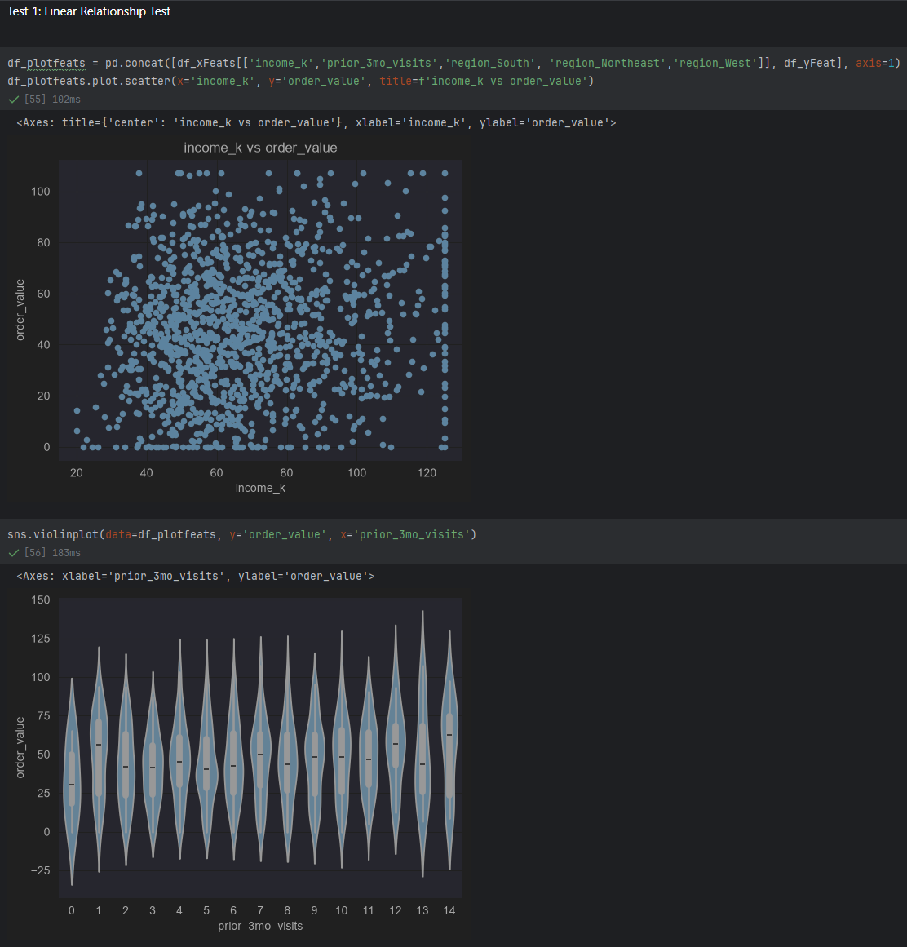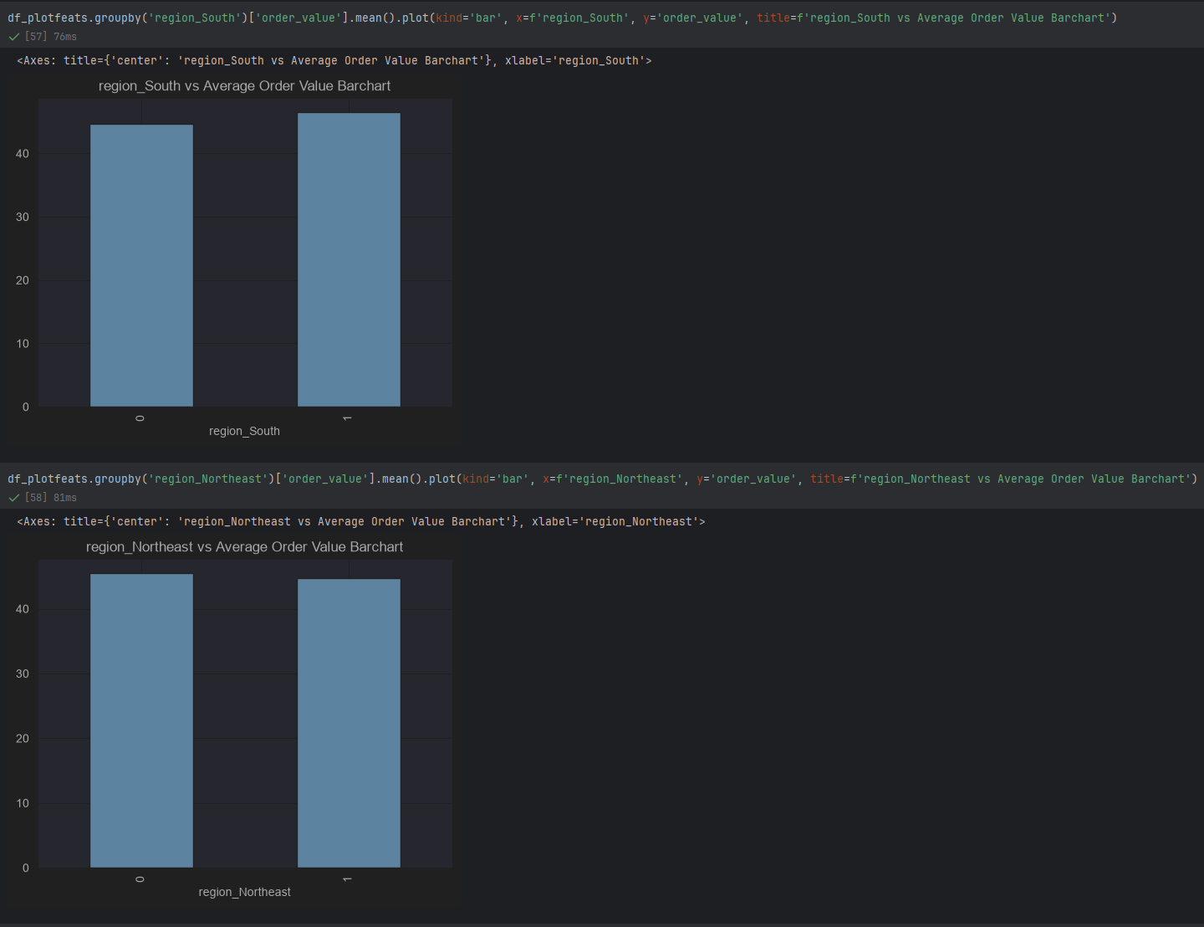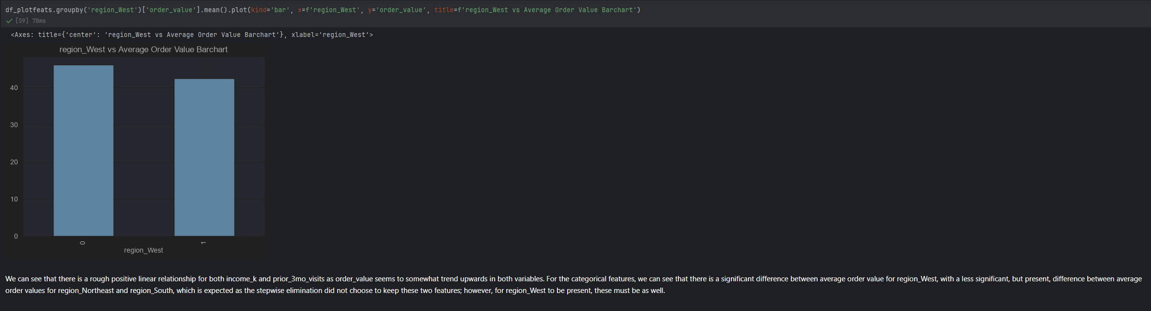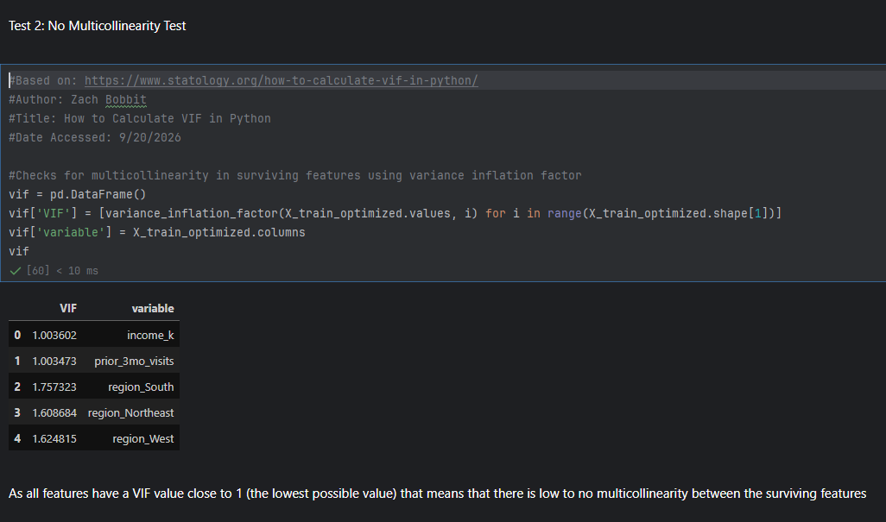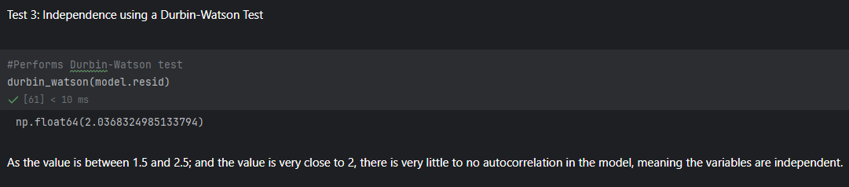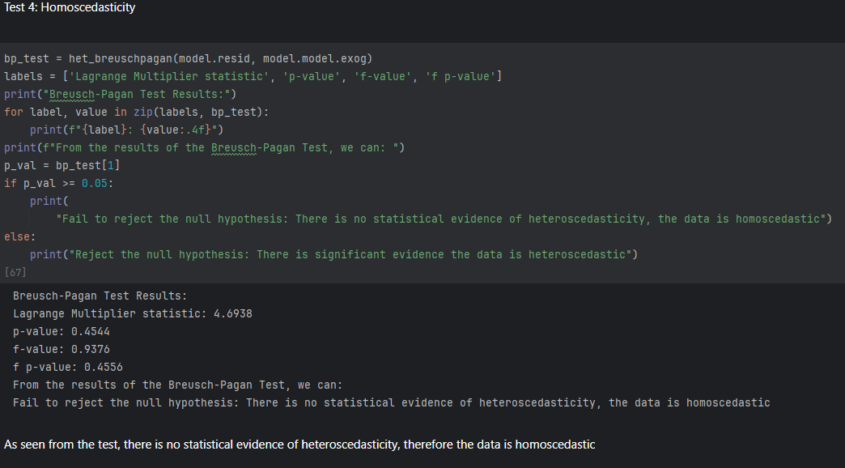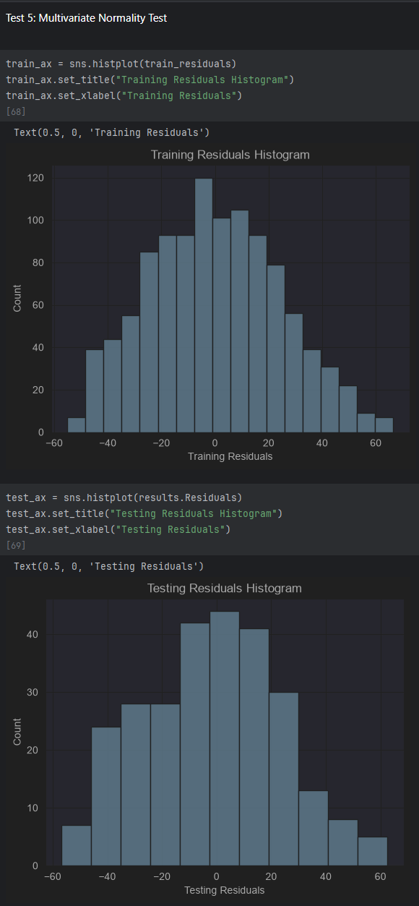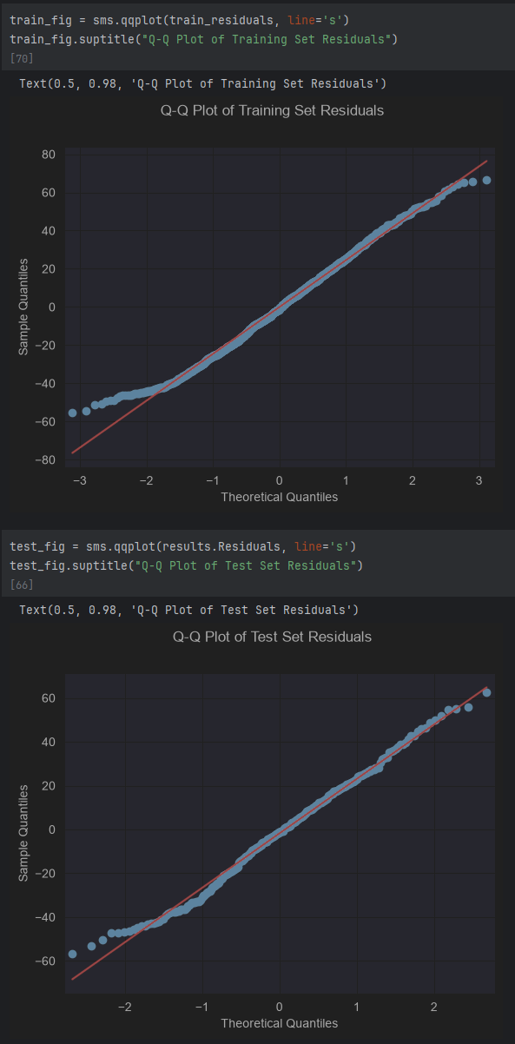
Justification: I decided to test the assumptions of multiple linear regression to ensure that the results of the study could be reliable, regardless of the final hypothesis or conclusions (Bobbit, 2021).
Advantages: Many of the methods used to test the assumptions use p-values, meaning they are easy to interpret.
Disadvantages: Some of the assumptions are tested through visualizations, meaning that they can be interpreted differently from person to person.
- Outcomes and Implications
- Root Mean Squared Error (RMSE) and Mean Absolute Error (MAE)
Both the training and test sets RMSE were calculated, their values were 24.6166 and 24.9194 respectively, the difference being 0.3027. Alongside these values, the MAE of each were also calculated, their values being 20.1197 and 20.2808, respectively, the difference between these values is 0.1611. For reference, the intercept, or constant, in our equation, discussed later, is ~45, meaning that the RMSE and MAE for both the train and test sets are very large, meaning that the model cannot predict order values accurately. The main reason to compare the RMSE and MAE of train and test sets is not to see how large the error is, as discussed in the next section, we will learn the accuracy of the model. Instead, these values are meant to check for over-and underfitting, which means the difference between the train and test values is the most important attribute. As seen above, the RMSE and MAE differences are small, with the MAE differences being very small. With the way that these values are calculated, the difference between the RMSE and MAE differences is expected. As the RMSE and MAE difference values are not significantly large, that means that there is little to no over-or underfitting. As RMSE punishes outliers more than MAE, it is typical for RMSE to be larger, as it is not larger by a significant margin, there are not any large errors made in the model that MAE does not also pick up, meaning there is little error due to outliers. Overall, we can see that although the model is inaccurate, it is not over-or underfit, nor is it heavily affected by outliers.
- $R^{2}$ Score and Adjusted $R^{2}$ Score
The next statistics calculated are the $R^{2}$ and adjusted $R^{2}$ score of both the train and test models. The $R^{2}$ scores of the train and test models are both 0.035. The adjusted $R^{2}$ scores are 0.031 and 0.0306 for the train and test models respectively. From these values we can see that the predictive power of the model is very poor and can only account for a very small amount of the variance in the data. At best, the model can account for 3.5% of the variance, but as this value is so small, it could be seen as non-existent. The adjusted $R^{2}$ score of model models is only slightly less than their respective $R^{2}$ scores, meaning the effect of adding additional region variables did not impact the adjusted $R^{2}$ scores heavily. Overall, we can say that the model is very poor at predicting order value price.
- Regression Equation
Although the regression model is very poor at predicting order value, we can still create a regression equation as if it were a good model. This equation being: Order Value = 45.56 + 3.95('z-score income_k') + 2.01('z-score prior_3mo_visits') + 0.25('z-score region_South') + -0.64('z-score region_Northeast')+ -1.87('z-score region_West'). The equation uses the z-score of the variables due to the scaler we used, so, if the model predicted order value accurately. We could say that for each standard deviation away from center for the income_k and prior_3mo_visits variables, order value changes by 3.87 and 1.93 respectively. For the other variables, as they are true/false variables, there are only two possible values, the true and the false, which are not 0 and 1, they are determined by the standard deviation away from center, the average. For example, region_South can have the values -0.7378 or 1.3553, meaning when the value is false, it is the negative value, and when its true it is the positive value. The other values for the remaining variables are -0.5251 and 1.9044 for region_Notheast and -0.5394 and 1.853703 for region_West. There can be at most one true value in all the region_ prefix variables as a customer can only be in one region; however, they can all be false as the baseline value is region_East as seen during data processing. With the categorical variables it can be hard to interpret the equation as it is not as simple as multiplying the coefficient by 0 or 1; however, we can easily see that having a customer not in the Northeast or West region’s improve order_value, if the model were able to make accurate predictions. The constant of 45.56 is the predicted value of an order as a baseline, or when all variables have a z-score of 0, which due to the categorical variables is not possible. Although the model is very poor at predicting values, a regression equation based on the model can still be created using coefficients and a constant.
- Validating the Assumptions of Multiple Linear Regression
As stated by Bobbit, there are five assumptions that must be met for the results of a multiple linear regression equation to be reliable; these assumptions are: a linear relationship between each predictor variable and the response variable, no multicollinearity, independence in observations, homoscedasticity, and multivariate normality (Bobbit, 2021). Below are the tests and results for each assumption. Below each test’s results, I will include a screenshot of the visualizations/tests.
- Bivariate Visualizations | Linear Relationship Test
To test for linear relationships, I created bivariate visualizations like how I did during data cleaning and processing for the selected variables used in the test model. These visualizations showed a rough positive linear relationship between the selected predictor variables, and the dependent variable, order value.
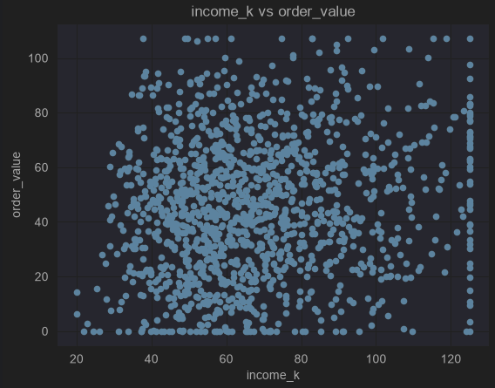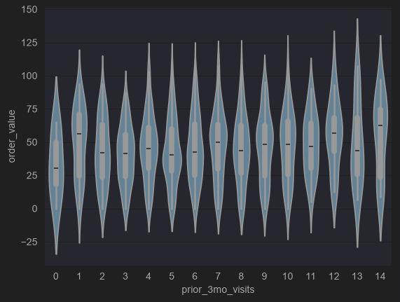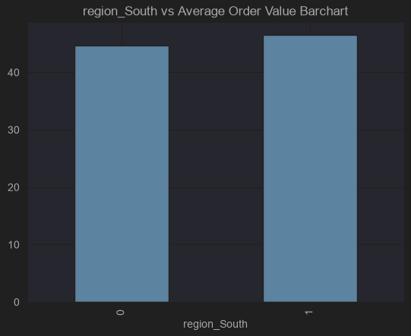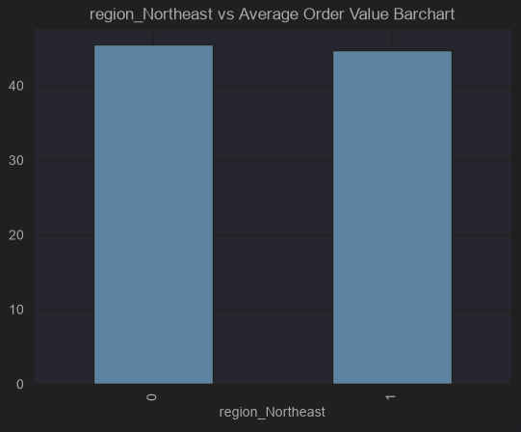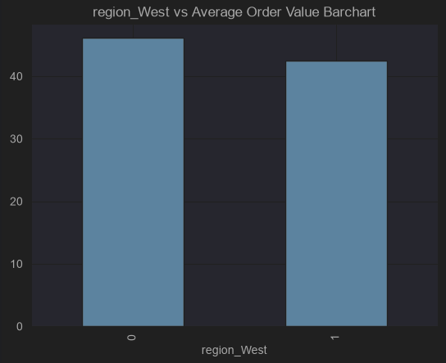
- Variance Inflation Factor (VIF) | Multicollinearity Test
The first of five tests to check the assumptions made by multiple linear regression is a test for multicollinearity. The VIF of a variable is the variance correlation between independent variables, multicollinearity, A value of 1 is the lowest possible value, meaning no multicollinearity. The values for both selected features were very close to 1, being 1.001362 for both features. This is expected as the model is very poor at predicting, the feature selection phase could have easily selected the two features with the least correlation. From this test, we can see that there is no multicollinearity.
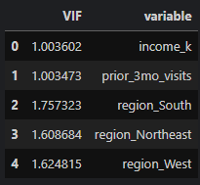
- Durbin-Watson Test | Independence Test
The Dubin-Watson test checks for autocorrelation in model residuals, as the assumption of multiple linear regression is that there is no correlation between consecutive residuals, this test is perfect for this assumption. The results of this test showed a test statistic of 2.0368. The closer this value is to 2, the lower the autocorrelation, with values below being negative serial correlation and positive values showing positive serial correlation. As the test statistic is very close to 2, we can presume there is very little autocorrelation, meaning this assumption is true.
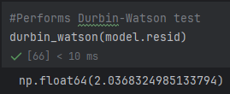
- Breusch-Pagan Test | Homoscedasticity Test
The final tests to check the assumptions made by multiple linear regression is a homoscedasticity test using a Breusch-Pagan test (Bobbit, 2021). Homoscedasticity tests for the consistent variance of residuals. For this test, the closer the f-value is to 1, the closer the variances, meaning that there is lack of evidence for heteroscedasticity, the inverse of homoscedasticity. The f-value is 1.2225, meaning that there is little variance. The p-value of the test is 0.2943, meaning that there is lack of evidence for heteroscedasticity, meaning that there must be homoscedasticity. Overall, the assumption of homoscedasticity presence can be seen as true due to the p-value and f-value of the Breusch-Pagan test.
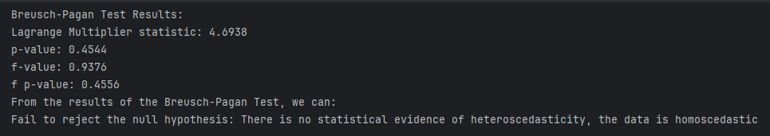
- Q-Q Plot and Histograms of Model Residuals | Multivariate Normality Test
The second of three tests to check the assumptions made by multiple linear regression is multivariate normality, by utilizing visualizations made with model residuals (Bobbit, 2021). As the check for normal distribution is using visualizations, refer to the previous section to see the visualizations. From these visualizations, we can see the residuals are roughly normally distributed with a slight right skewedness in the histograms. From the tails of the q-q plot, we can see that the data is slightly under-dispersed, meaning that there is lower variance in the residuals. The residuals from the train and test models are used to check for the normal distribution of the model’s predictions through checking the unexplained errors. Overall, the assumption of normal distribution is true, as the slight right-skewedness and under dispersion of the data still allow for normal distribution to be true.
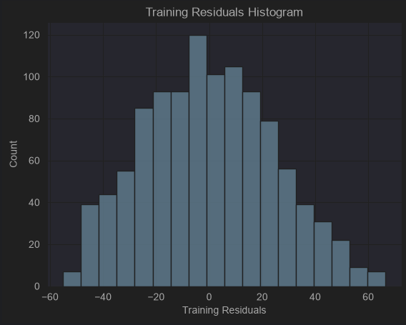
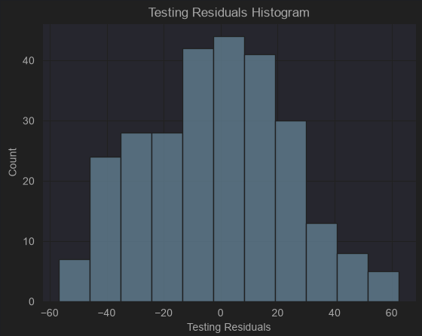
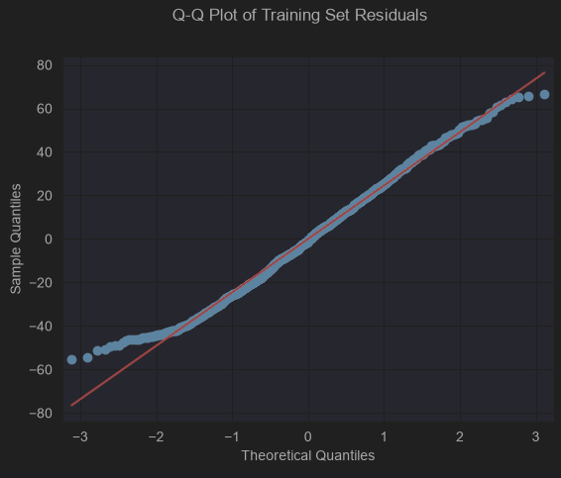
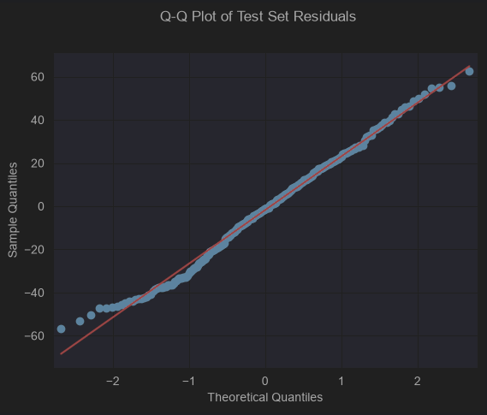
- Overall Conclusions
From the statistics and tests calculated and performed, we can see that the assumptions of multiple linear regression were in fact true, but this does not change the fact that the model is poor at predicting e-commerce customer order values, only capturing a low percentage of the variance, with very large errors occurring across all values.
- Outcomes
  - Limitations and Delimitations
Multiple linear regression simply examines the correlation between multiple features and a dependent variable and cannot establish direct causation. Order values of 0 were not predicted as I only attempted to predict order values from sales with purchases.
  - Course of Action
As the model cannot accurately predict e-commerce customer order value, I believe the two options laid out in the Further Studies section are two choices that can be made to either continue attempting to predict customer order values or predicting whether a customer will make a purchase. The course of action that may be the most fruitful would be performing logistic regression to predict whether a customer will make a purchase due to the lack of explained variance found in the study towards predicting the value of the orders. As seen in the assumption test section, there was a rough linear correlation between the numeric variables and the dependent variable, polynomial regression may be able to capture more of the variance in the variables in the dataset leading to more accurate predictions.
  - Further Studies
    - Option 1: Continuing to attempt prediction of e-commerce customer order value. More data could be collected to hopefully capture the variance in order values. Perhaps, the influencing variables of order value were not initially collected. Another option could be to perform a different type of regression to attempt to capture more variance, that being polynomial regression.
    - Option 2: Pivoting to a different prediction-based research question. Attempting to predict whether a customer will make a purchase or not could be another problem that could be solved by the variables in the dataset.
Sources
Alaudeen, M. N. (2025, November 29). The ultimate guide to regression metrics: Choose the right one every time | by Mohamed Noordeen alaudeen | learning data | medium. Medium. https://medium.com/learning-data/the-ultimate-guide-to-regression-metrics-choose-the-right-one-every-time-72aada435ee7
Biswas, A. (2026, March 9). Beyond prediction: Why statsmodels is essential for statistical inference in Python | by Abhishek Biswas | Medium. Medium. Retrieved September 17, 2026, from https://medium.com/@abhishek.biswas.1998/beyond-prediction-why-statsmodels-is-essential-for-statistical-inference-in-python-1b3cacb2fa81
Bobbitt, Z. (2021, November 16). The five assumptions of multiple linear regression. Statology. Retrieved September 17, 2026, from https://www.statology.org/multiple-linear-regression-assumptions/
Bobbitt, Z. (2022, January 25). The breusch-pagan test: Definition & Example. Statology. https://www.statology.org/breusch-pagan-test/
Couto da Silva, C. M. (2025, March 23). Winsorization: Handling outliers in machine learning. Train in Data Blog. Retrieved September 17, 2026, from https://blog.trainindata.com/winsorization-handling-outliers-in-machine-learning/
İnce, M. N., & Taşdemir, Ç. (2024). Forecasting Retail Sales for Furniture and Furnishing Items through the Employment of Multiple Linear Regression and Holt–Winters Models. Systems, 12(6), 219. Retrieved September 17, 2026, from https://doi.org/10.3390/systems12060219
Lin, A. (2024). Walmart sales prediction using multiple linear regression. Highlights in Science, Engineering and Technology, 107, 124–129. Retrieved September 17, 2026, from https://doi.org/10.54097/my1nfb95
Pereira, R. (2026, May 5). R vs python vs SAS in a modern SCE: What pharma teams should choose. RSS. Retrieved September 17, 2026, from https://www.appsilon.com/post/r-python-sas-modern-sce-comparison
Saluja, M. S. (2024, July 15). Variance inflation factor (VIF). the variance inflation factor (VIF)… | by mandeep singh saluja | medium. Medium. https://medium.com/@Mandeep2002/variance-inflation-factor-vif-f6ee0f6bcc71
Sewell, W. (2026, January 26). Retail_Sales_10K (Version 1) [Data Set]. Kaggle. Retrieved September 17, 2026, from https://www.kaggle.com/datasets/williamsewell/retail-sales-10k
Team, I. C. (2024, August 21). Python vs. R: What’s the difference? IBM. Retrieved September 17, 2026, from https://www.ibm.com/think/topics/python-vs-r
Waples, J. (2024, November 17). The Q-Q plot: What it means and how to interpret it | datacamp. datacamp. Retrieved September 17, 2026, from https://www.datacamp.com/tutorial/qq-plot

